Python File Opening Modes:
a, a+, w, w+, and r+
Pointer Positions · Truncation · Read/Write Behavior · Best Practices
A Comprehensive Academic Research Paper
2026

Abstract
Python's built-in open() function provides five core modes for file manipulation: a, a+, w, w+, and r+. Understanding these modes is critical to avoid data loss, accidental overwrites, and file pointer errors — among the most common bugs in Python file I/O. This paper provides a systematic analysis of each mode's behavior: pointer position, truncation, read/write permissions, file creation rules, and common pitfalls. Visual diagrams, worked examples, and a decision flowchart guide practitioners to always choose the correct mode.

1. Introduction
File I/O is a fundamental skill in Python programming. The open() function's mode parameter determines how Python interacts with the file:
- What operations are allowed: read, write, or both.
- Where the file pointer starts: beginning (position 0) or end (position EOF).
- What happens to existing content: preserved, truncated, or appended to.
The + symbol always enables both reading and writing — but it does NOT change where the pointer starts. That depends on the base mode (r, w, or a). This is the most common source of confusion.
Key Rule: "+" adds read/write capability. The base letter (a, w, r) controls pointer position and truncation behavior.

2. File Pointer Positions
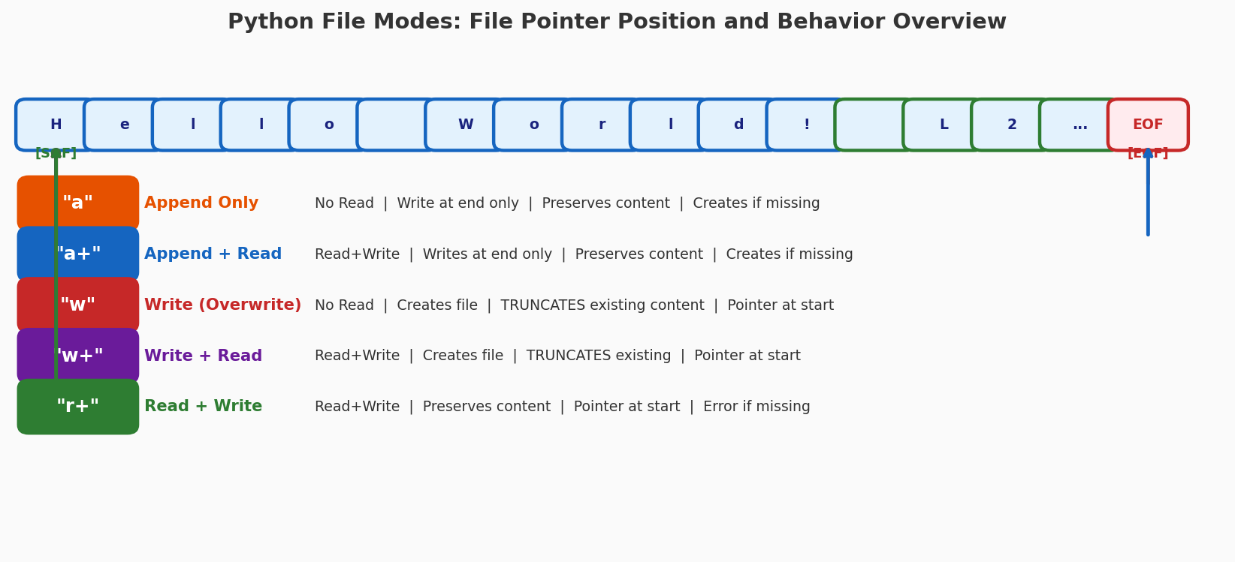
Figure 1: File pointer starting positions for all five modes. Append modes (a, a+) start at EOF; write/read modes (w, w+, r+) start at the beginning (SOF).

2.1 The File Pointer
The file pointer is an internal cursor tracking the current read/write position in the file. Every read/write operation advances the pointer by the number of bytes processed. Understanding where the pointer starts — and how to move it with seek() — is essential for correct file handling.
Mode | Read | Write | Pointer Start | Truncates | File Missing
a | No | Yes (append) | End (EOF) | No | Creates
a+ | Yes | Yes (append) | End (EOF) | No | Creates
w | No | Yes | Start (SOF) | Yes | Creates
w+ | Yes | Yes | Start (SOF) | Yes | Creates
r+ | Yes | Yes | Start (SOF) | No | Error

Table 1: Complete summary of all five file modes

3. Mode-by-Mode Analysis

3.1 Append Mode: "a"
"a" mode | open("file.txt", "a") → Write-only | Pointer at EOF | No truncation

- Writes data ONLY at the end of the file — regardless of seek() calls.
- Existing content is always preserved (never truncated).
- File is automatically created if it does not exist.
- Reading is NOT allowed — use "a+" for that.
- Best use: Log files, audit trails, append-only data streams.

3.2 Append + Read: "a+"
"a+" mode | open("file.txt", "a+") → Read+Write | Pointer at EOF | No truncation

- Combines read capability with append-only writing.
- CRITICAL: Pointer starts at EOF. To read existing content, you MUST call f.seek(0) first.
- Writing always appends to end regardless of pointer position.
- Best use: Append new records while occasionally reading existing ones.

3.3 Write Mode: "w"
"w" mode | open("file.txt", "w") → Write-only | TRUNCATES | Pointer at start

- WARNING: IMMEDIATELY TRUNCATES the file to 0 bytes on opening — even before any write.
- All previous content is permanently destroyed.
- Creates the file if it does not exist.
- Best use: Creating new files or completely replacing existing content.

3.4 Write + Read: "w+"
"w+" mode | open("file.txt", "w+") → Read+Write | TRUNCATES | Pointer at start

- WARNING: Like "w", immediately truncates the file on opening.
- After writing, pointer is at end of written content — call f.seek(0) to read it back.
- Common pitfall: f.write("Hello") then f.read() returns "" because pointer is now at EOF.
- Best use: Create and immediately read back a temporary file in the same session.

3.5 Read + Write: "r+"
"r+" mode | open("file.txt", "r+") → Read+Write | No truncation | Pointer at start

- Preserves all existing content — does NOT truncate.
- ERROR: Raises FileNotFoundError if the file does not exist (unlike a, w, a+, w+).
- Writing in "r+" overwrites existing bytes in-place — does not insert or shift content.
- Best use: Modifying specific parts of an existing file in-place.

4. Truncation Behavior Illustrated
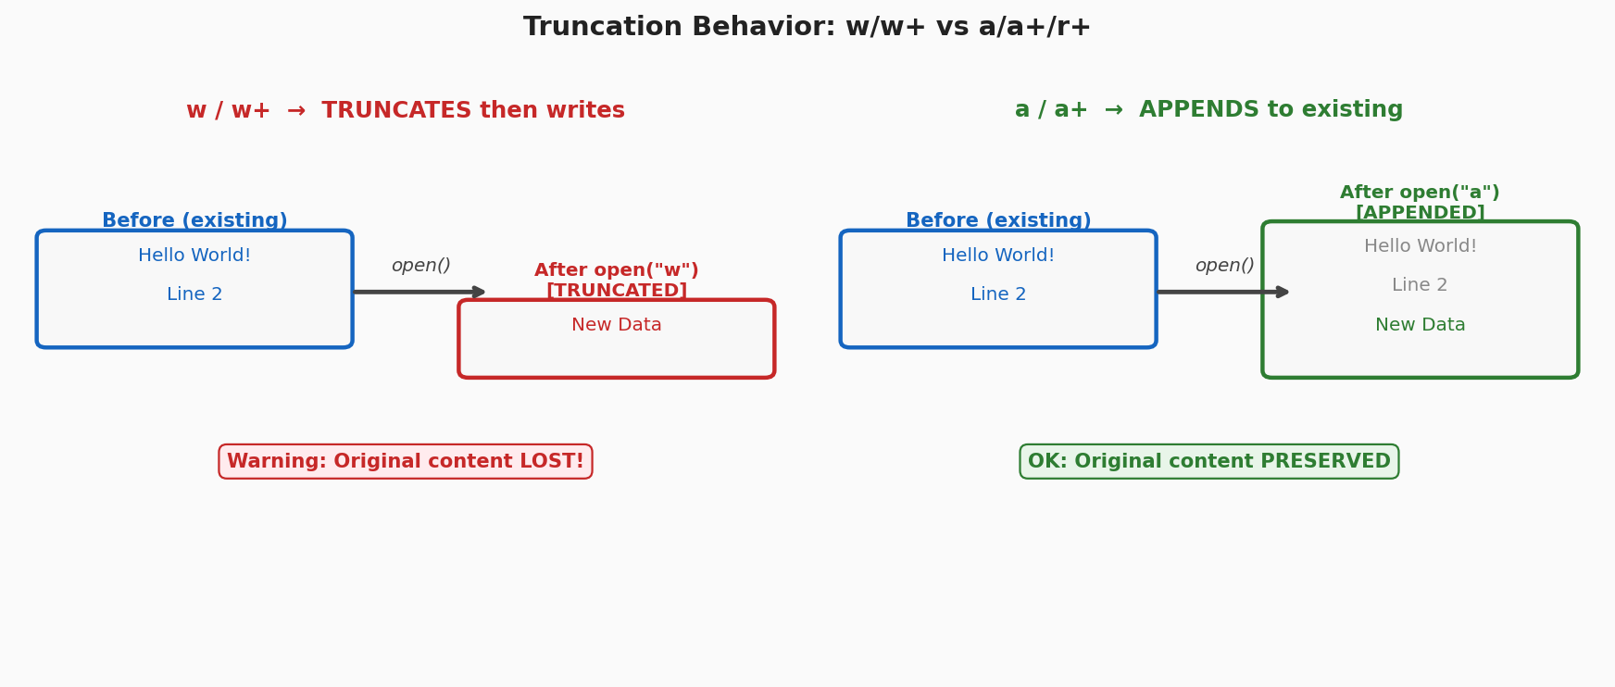
Figure 2: Left — w/w+ immediately truncates existing content on opening. Right — a/a+ preserves all existing content and appends new data after it.

5. Feature Comparison Matrix
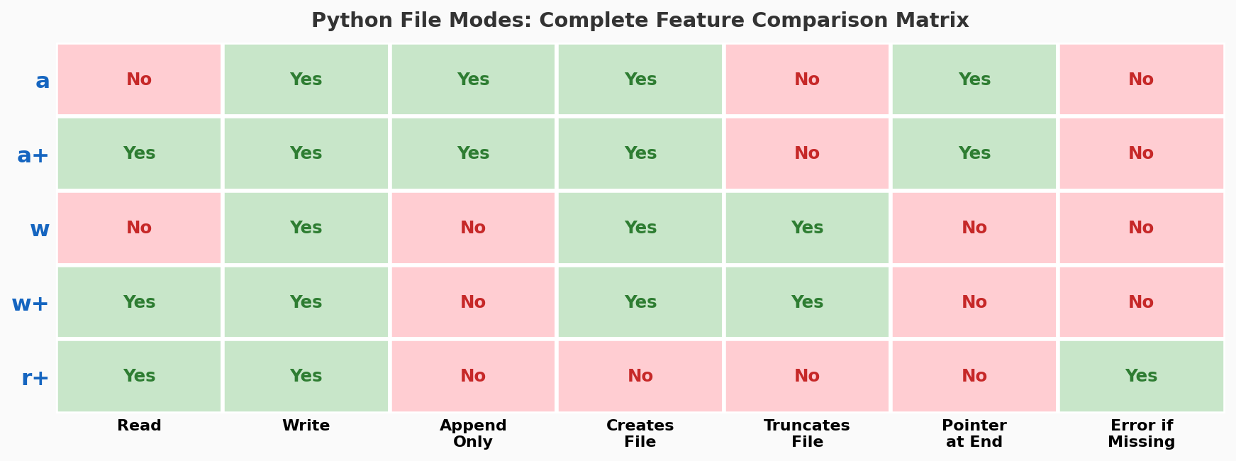
Figure 3: Complete feature matrix for all five modes. Green = Yes, Red = No. Notice that only "a" and "a+" start at end-of-file.

6. Common Pitfalls and Fixes
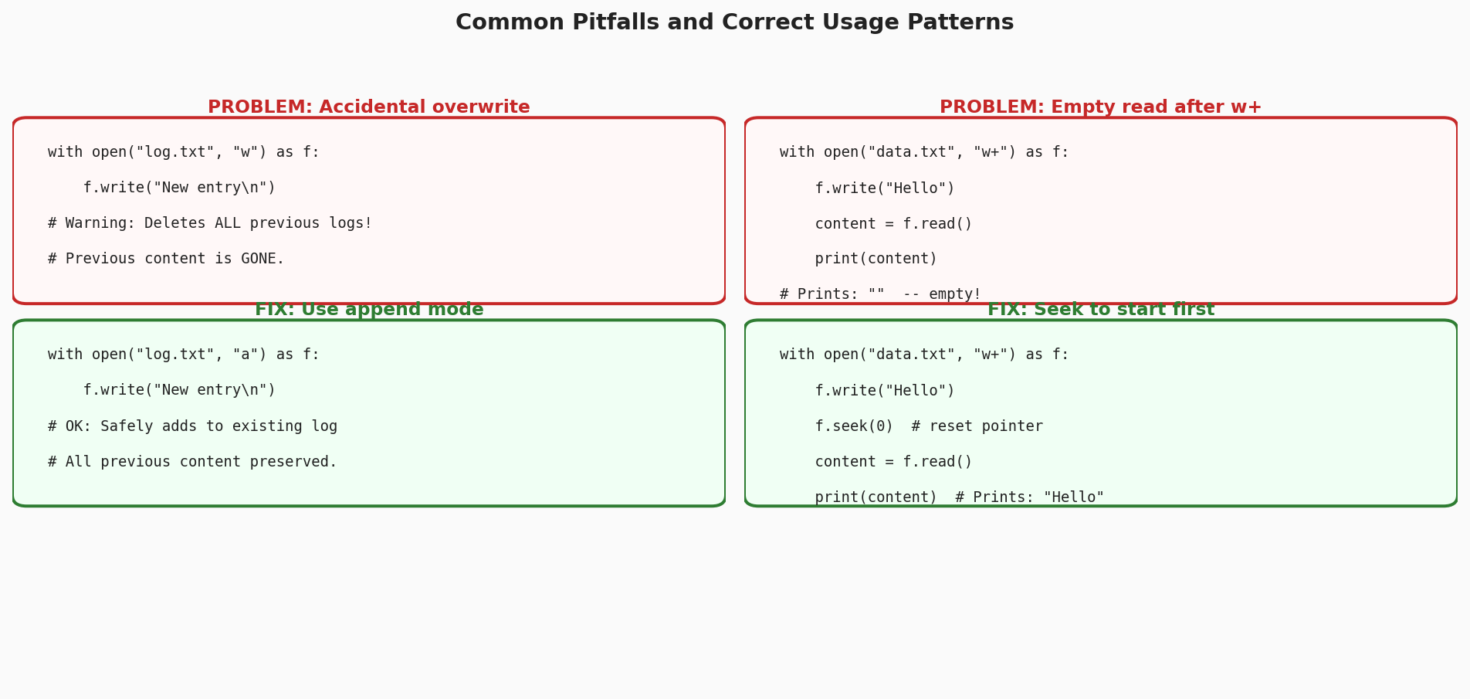
Figure 4: Two most common file mode mistakes and their correct solutions. Left: using "w" for logging (loses data). Right: reading after "w+" without seek(0) (returns empty string).

6.1 Pitfall: Accidental Data Loss with "w"
Problem: Using "w" mode to add a log entry destroys all previous logs because "w" truncates the file immediately.
Fix: Always use "a" for appending. Only use "w" when you explicitly intend to replace all content.

6.2 Pitfall: Empty Read After "w+"
Problem: After writing with "w+", calling f.read() returns an empty string because the pointer is at EOF after the write.
Fix: Call f.seek(0) to reset the pointer to the beginning before reading. This is essential for all write modes when you want to read back what was written.

6.3 Pitfall: "r+" on Missing File
Problem: "r+" raises FileNotFoundError if the file doesn't exist. Developers often expect it to create the file like "w+" does.
Fix: Use "w+" if the file may not exist and you don't mind truncation. Or check os.path.exists() before opening with "r+".

7. Decision Guide: Choosing the Right Mode
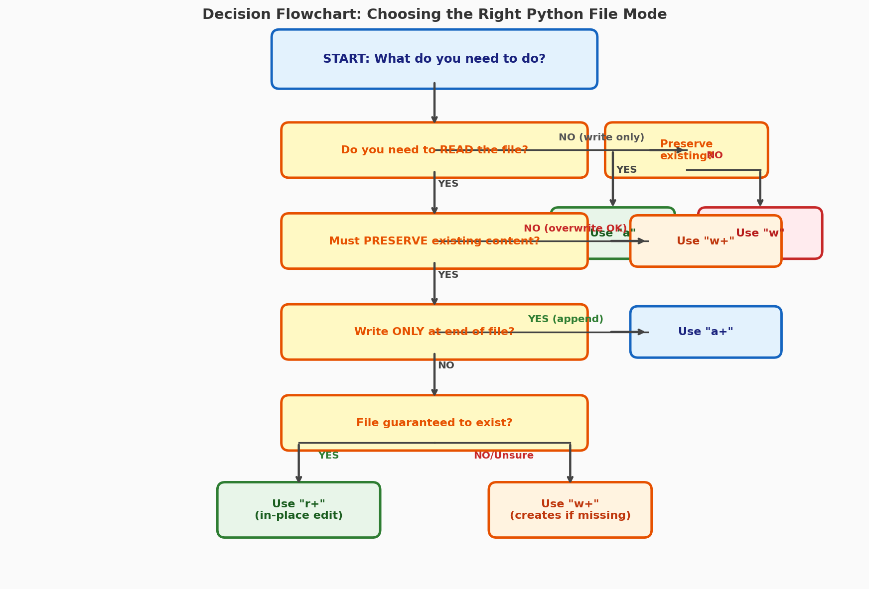
Figure 5: Decision flowchart — answer 4 questions to always select the correct file mode.

Use Case | Correct Mode | Why
Append to log file | a | Write-only at end, no truncation
Read + append new records | a+ | Read anywhere + append write
Replace entire file | w | Truncates and rewrites from scratch
Create temp, read back | w+ | Create + read in same session
Edit part of existing file | r+ | In-place, no truncation
Read only | r | Read-only, safest option

Table 2: Quick reference guide for selecting the right file mode

8. Conclusion
Python's five file modes (a, a+, w, w+, r+) cover all file I/O scenarios but require careful selection to avoid silent data loss. The two most important rules are: (1) never use "w" when you mean to append — use "a" instead; (2) always call f.seek(0) before reading after a write operation in "w+" or "a+" modes.
Summary: a = append-only. a+ = append + read. w = write (DESTROYS file). w+ = write + read (DESTROYS file). r+ = read + write (file must exist, no truncation). The + adds read capability; it never changes pointer position or truncation behavior.

References
[1] Python Software Foundation. "Built-in Functions: open()." Python 3 Documentation, 2024. https://docs.python.org/3/library/functions.html#open
[2] Python Software Foundation. "io — Core tools for working with streams." Python 3 Library Reference, 2024. https://docs.python.org/3/library/io.html
[3] Real Python. "Working with Files in Python." Real Python Tutorials, 2024. https://realpython.com/working-with-files-in-python/
[4] GeeksforGeeks. "File handling in Python." GeeksforGeeks Python Tutorial, 2024. https://www.geeksforgeeks.org/file-handling-python/
[5] W3Schools. "Python File Open." W3Schools Python Reference, 2024. https://www.w3schools.com/python/python_file_handling.asp

